Practical No.4

Design and develop System Dynamic model by

• Creating a stock and flow diagram

• Adding a plot to visualize dynamics

• Parameter Variation

• Calibration

[ Use a case scenario like spread of contagious disease for the purpose]

**SEIR model**

We're about to build a model that displays the spread of a contagious disease

among a large population. Our sample model will have a population of 10,000

people – a value we call *TotalPopulation* – of which one person is infectious.

• During the infectious phase, a person comes into contact with an average

of *ContactRateInfectious* = 1.25 people each day. If an infectious person

comes into contact with a susceptible person, the susceptible person's

probability of infection is *Infectivity* = 0.6.

• After a susceptible person is infected, the infection latent phase lasts for

*AverageIncubationTime* = 10 days. We'll use the word *exposed* to describe

people who are in the latent phase.

• After the latent phase, infectious phase starts. This phase lasts for

*AverageIllnessDuration* = 15 days.

• Persons who have recovered from the disease are immune to a second

infection.

**Phase 1. Creating a stock and flow diagram**

Create a new model by selecting **File > New > Model** from the menu, and then

name it SEIR. Select **days** as the **Model time units**.

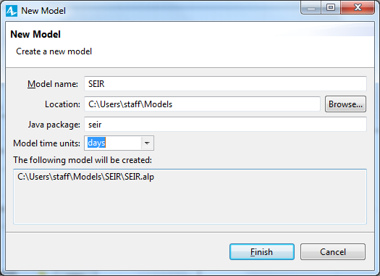

In this example, we'll

consider four important characteristics:

• Susceptible - people who are not infected by the virus

• Exposed - people who are infected but who can’t infect others

• Infectious - people who are infected and who can infect others

• Recovered – people who have recovered from the virus

SEIR is an acronym that represents the four stages: Susceptible-Exposed-

Infectious-Recovered. The terminology and the overall structure of the problem is

taken from the ("Compartmental models in epidemiology". n.d.) -- namely, from

the SEIR (Susceptible Exposed Infectious Recovered) model.

There are four stocks in our model - one for each stage.12.222

Open the **System Dynamics** palette. Drag the **Stock** from the **System**

**Dynamics** palette on to the diagram. Name it Susceptible.

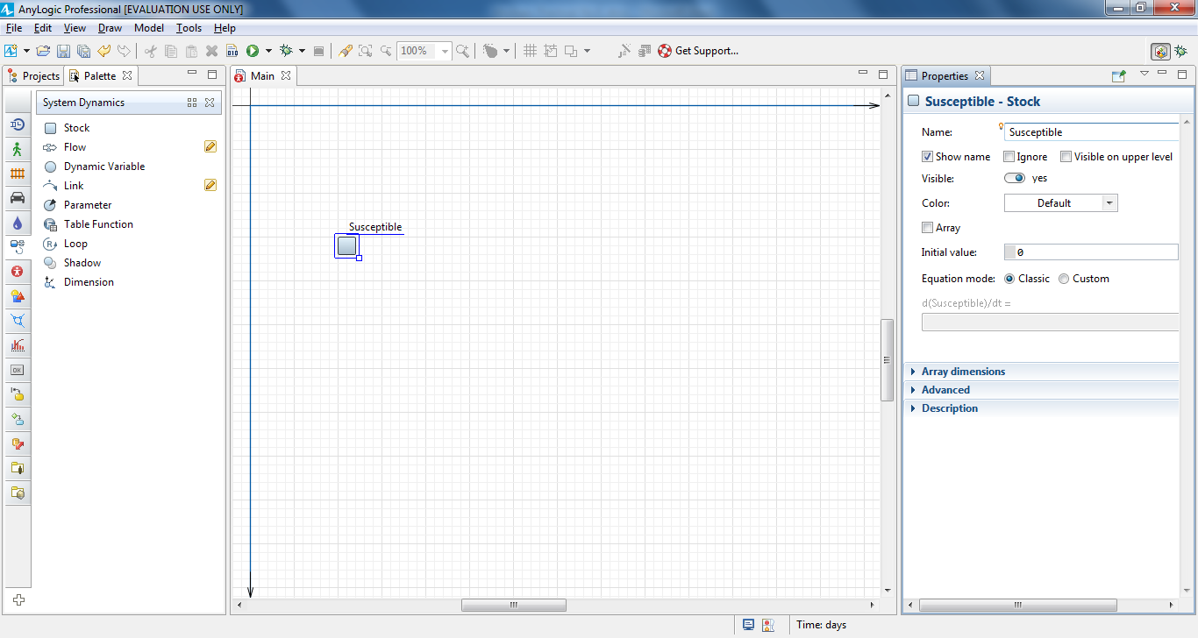

Add three more stocks. Place them as shown in the figure and name them

Exposed, Infectious, and Recovered.

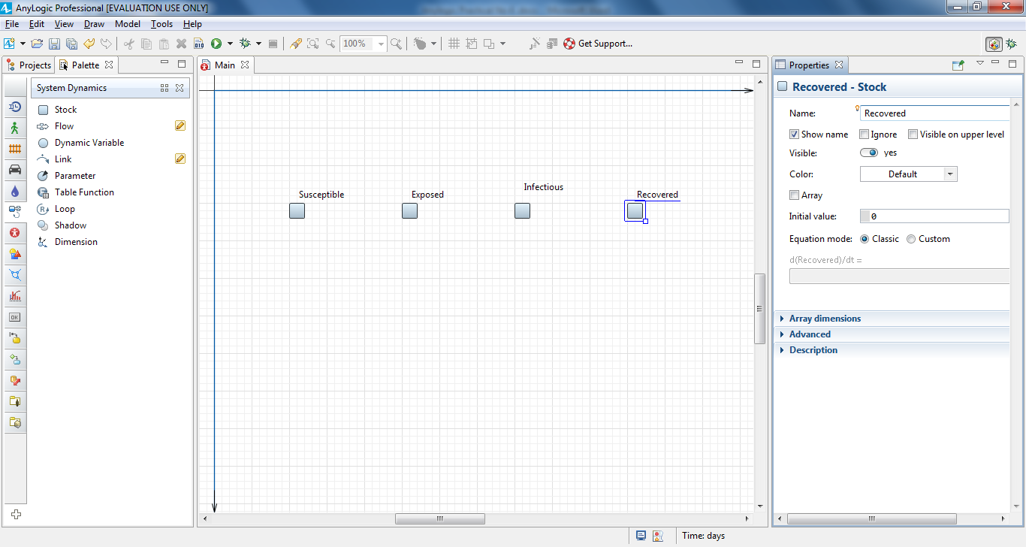

The flow’s arrow shows its direction.

In our model, susceptible people are exposed to the virus, become infectious, and

then recover. It's a progression that requires our model to use three flows to drive

people from one stock to the next.

Add the first flow that flows from the stock Susceptible to Exposed. Doubleclick

the stock where the flow flows out (Susceptible), and then click the stock

where it flows in (Exposed).

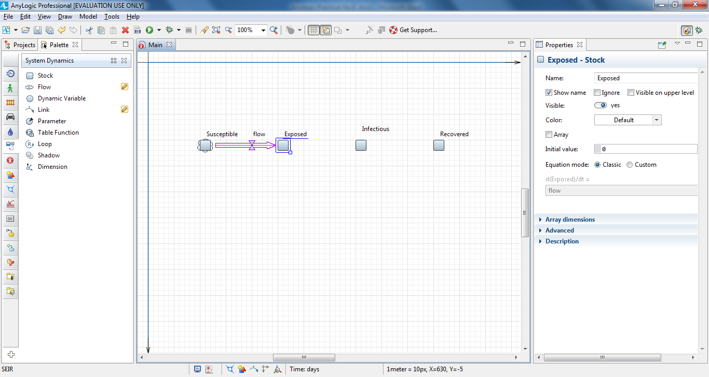

Name the flow ExposedRate.

Add a flow from Exposed to Infectious, and then name it InfectiousRate

Add a flow from Infectious to Recovered, and then name it RecoveredRate

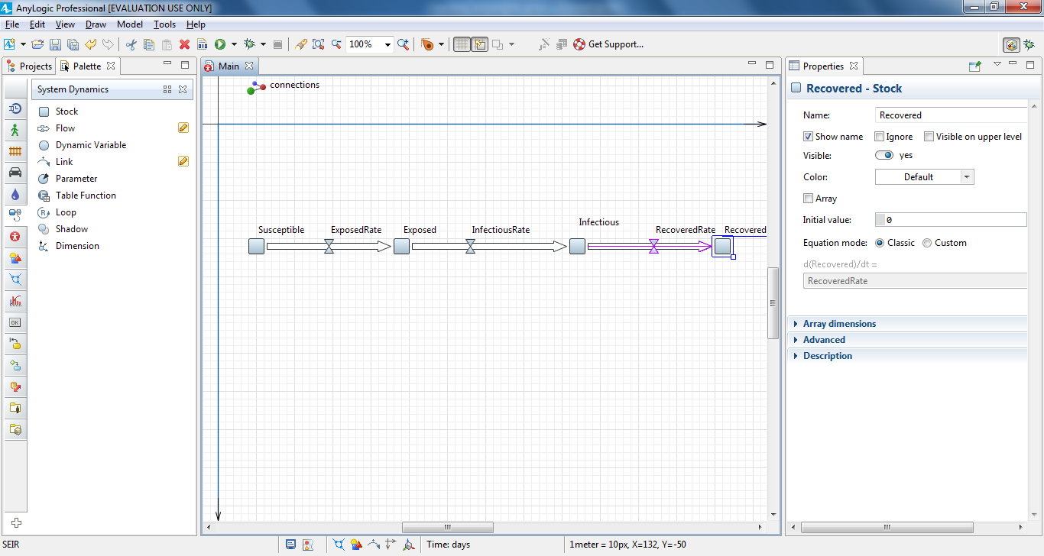

Rearrange the flow names as shown in the figure below. To do this, select a

flow and then drag its name.

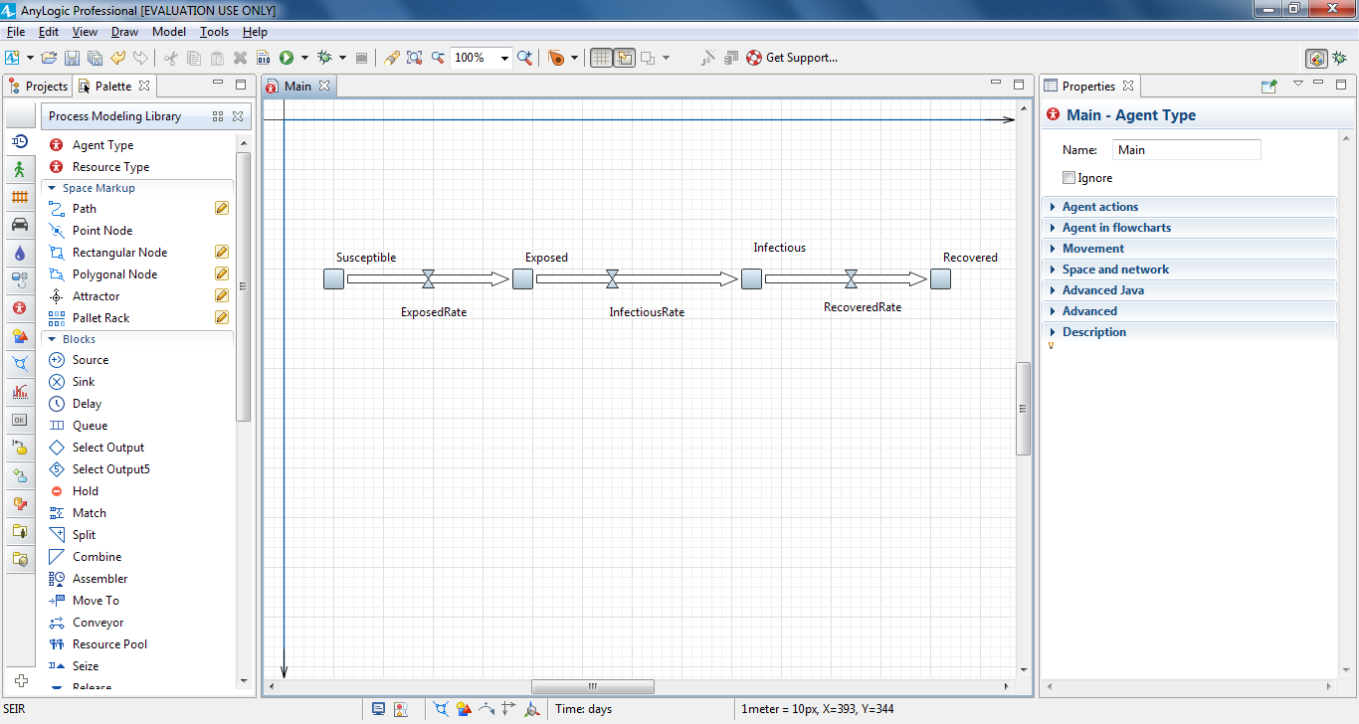

Add five **Parameters** ,

rename them, and define their default values according to the information

below:

**•** TotalPopulation = 10 000

**•** Infectivity = 0.6

**•** ContactRateInfectious = 1.25

**•** AverageIncubationTime = 10

**•** AverageIllnessDuration = 15

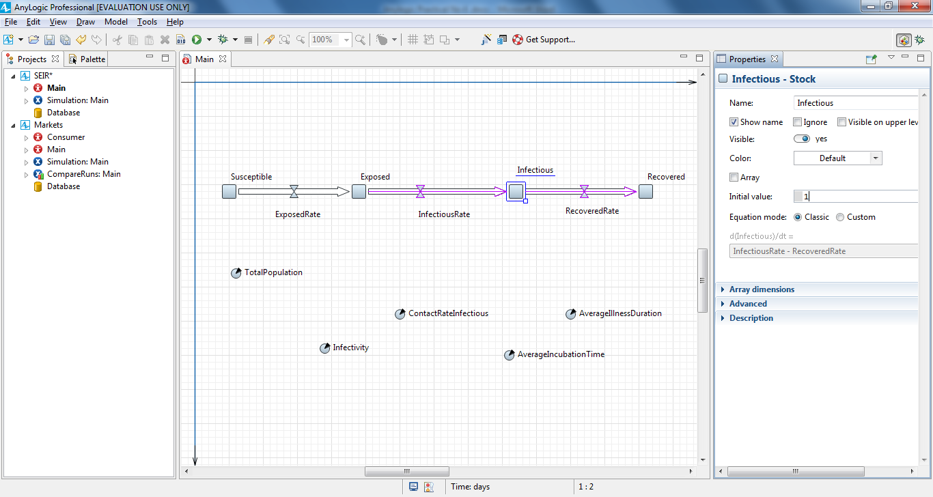

Define the number of infected people by specifying 1 as the **Initial Value** of the stock Infectious.Define the **Initial Value** for the stock Susceptible: TotalPopulation-1.

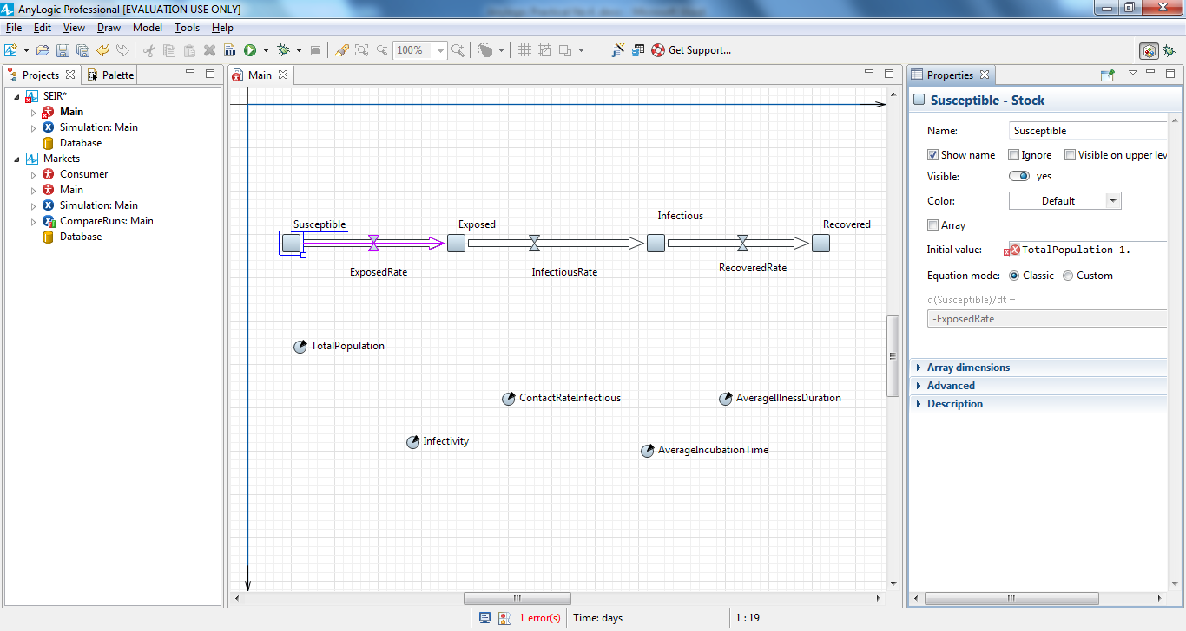

Draw a dependency link from TotalPopulation to Susceptible:

In the **System Dynamics** palette, double-click the **Link** element, click

TotalPopulation, and then click the stock Susceptible. You should see the link

with small circles drawn on its end points

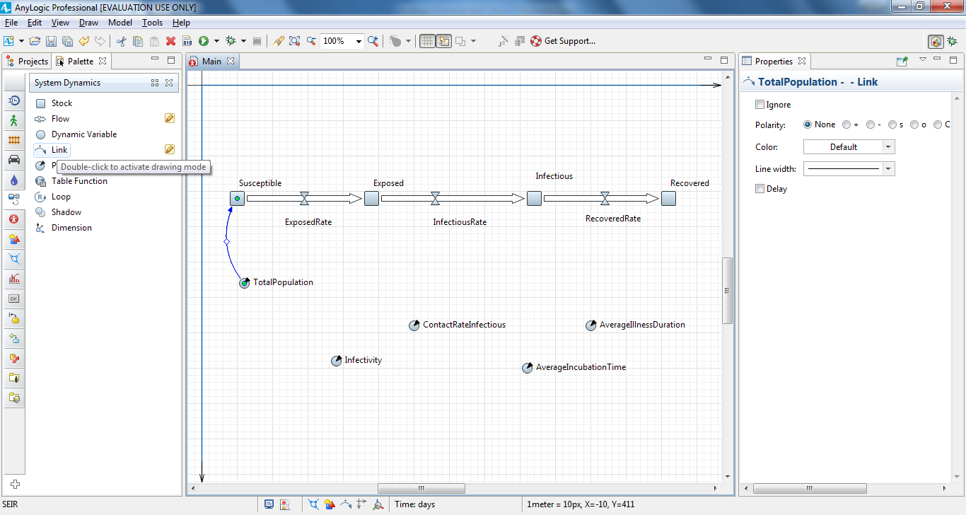

formula for the flow ExposedRate**.**

Click the flow and define the following formula using the Code Completion

assistant:

Infectious*ContactRateInfectious*Infectivity*Susсeptible/TotalPopulation

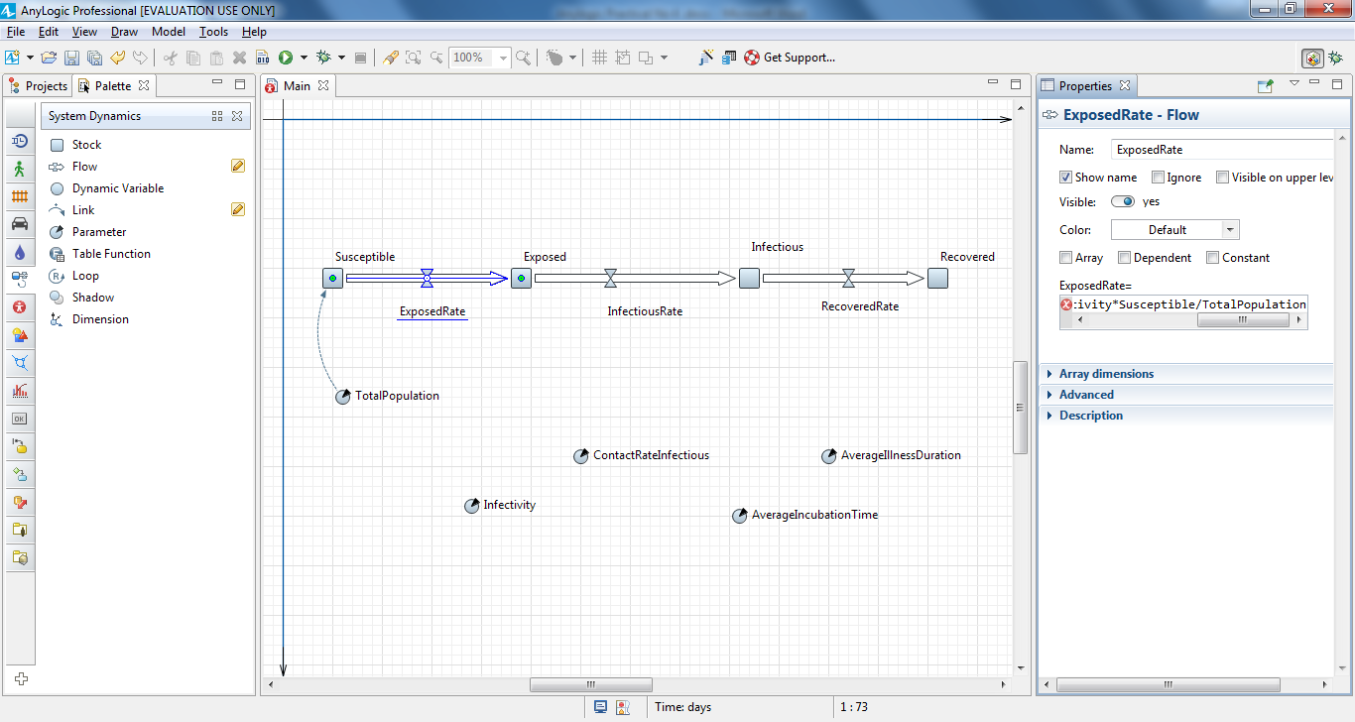

Right-click ExposedRate flow in the graphical diagram, and choose **Fix**

**Dependancy Links > Create Missing Links** from the context menu. Afterward, you

should see the links in the stock and flow diagram:

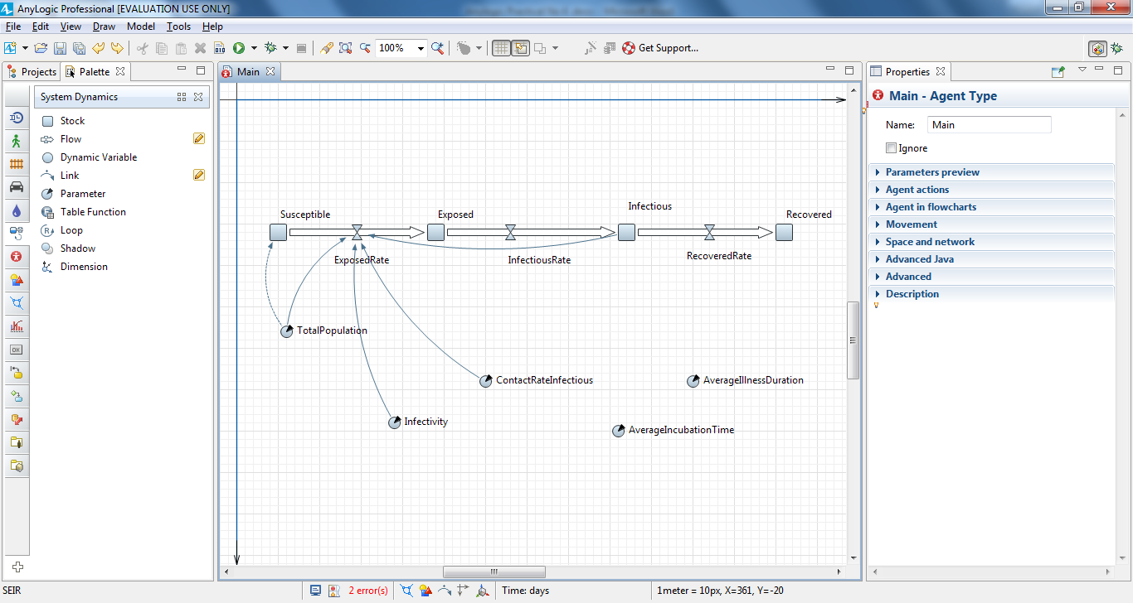

Define the following formula for InfectiousRate:

Exposed/AverageIncubationTime

Define the following formula for RecoveredRate:

Infectious/AverageIllnessDuration

Draw the missing dependency links, and your stock and flow diagram should

resemble the following image:

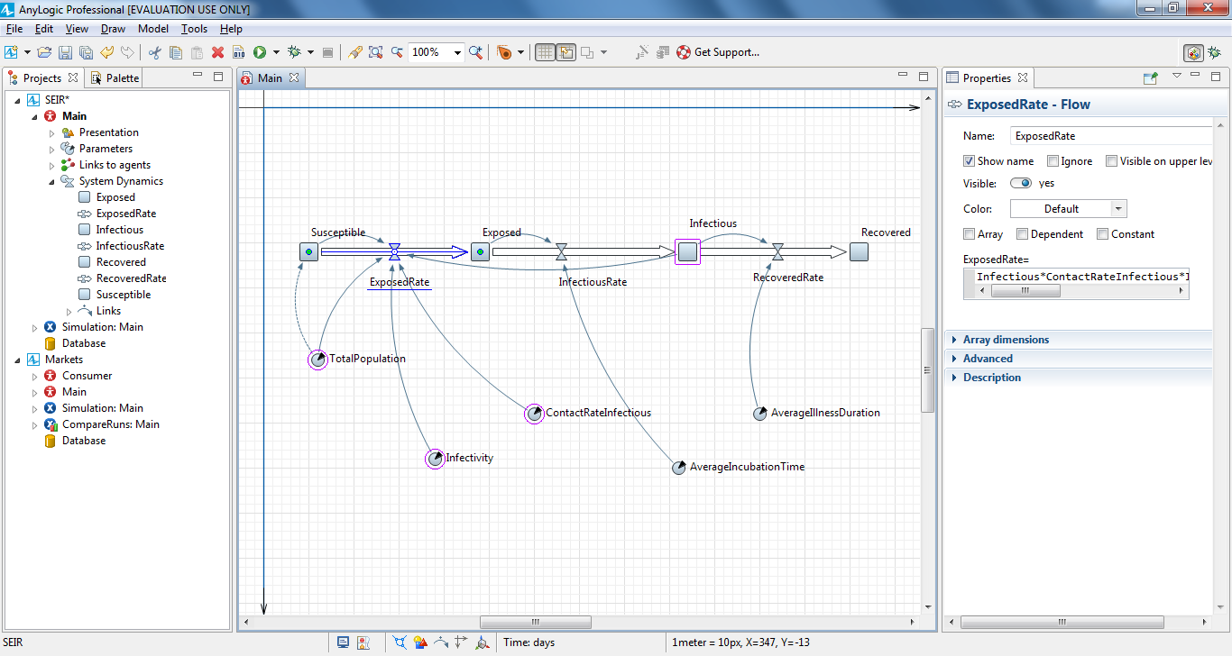

Adjust the appearance of dependency links. Modify the links’ bend angles to

make the diagram match the figure below. To adjust the link's bend angle,

select it, and then drag the handle in the middle of the link.

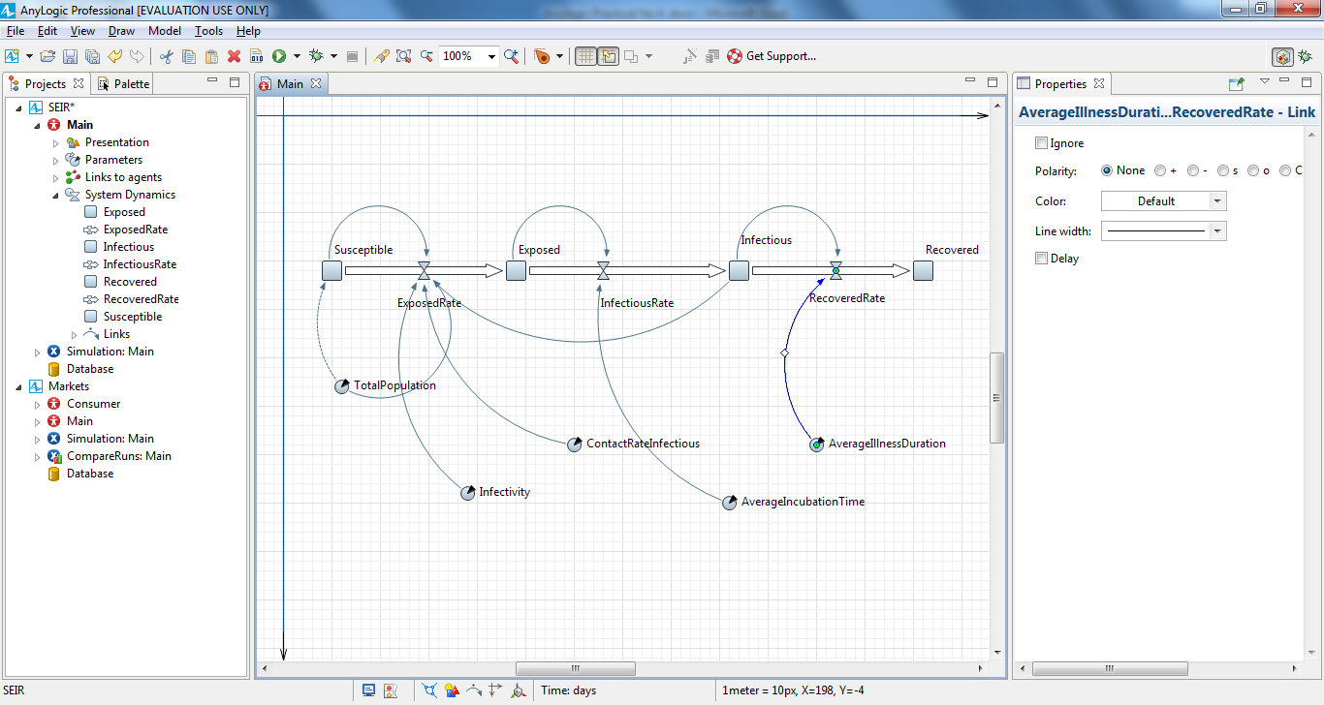

Run the model and inspect the dynamics using the variables' inspect

windows. To open a variable's inspect window, click the variable to select it.

To resize the window, drag its lower right corner.

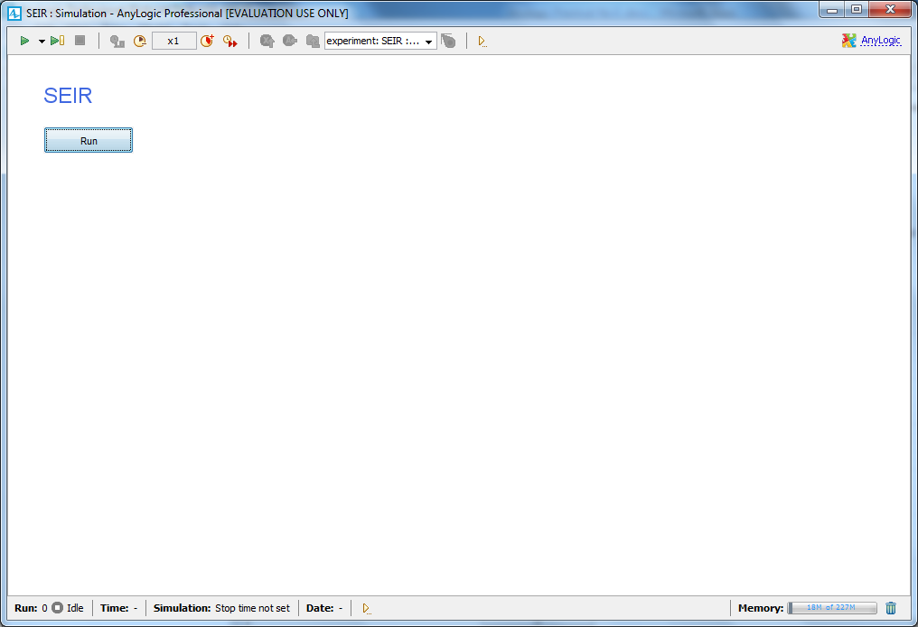

5 Design and develop a discrete-event model that will simulate process by:

• Creating a simple model

• Adding resources

• Creating 3D animation

• Modeling delivery

[Use a case situation like a company’s manufacturing and shipping].

6 Design and develop time-slice simulation for a scenario like airport model to

design how passengers move within a small airport that hosts two airlines, each

with their own gate. Passengers arrive at the airport, check in, pass the security

checkpoint and then go to the waiting area. After boarding starts, each airline’s

representatives check their passengers’ tickets before they allow them to board.

35

7 Verify and validate a model developed like bank model or manufacturing model

8 Create defense model to stimulate aircraft behavior

9 Stimulate the travelling sales man problem to compute the shortest path.

10 Stimulate the Urban dynamics to address the scenarios like:

(a) The problem of public transport line

(b) To compute the time taken for train to enter the station